THE IMPACT OF **ARTIFICIAL INTELLIGENCE** ON JOB MARKET AND WORKFORCE

* Introduction



1. What is artificial intelligence (AI)?

* Artificial intelligence is the simulation of human

intelligence processes by machines, especially

computer systems. Specific applications of AI

include expert systems, natural language

processing, speech recognition and machine vision.[1]

1. Growing prevalence and importance of AI

* Artificial intelligence (AI) is

becoming increasingly

important in business today.

With the ability to analyze

large amounts of data and

automate tasks, AI can help

businesses improve efficiency,

reduce costs, and make better

decisions. In my article, I'll

cite some of the ways in which

AI is being used in business

today and why, it is so important.[2]

The Impact of **Artificial Intelligence** on the Job Market

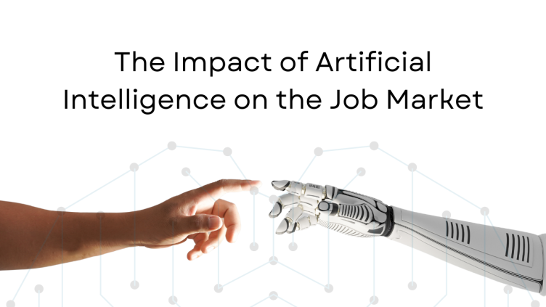

* As we delve deeper into the world of AI, it's becoming increasingly clear that it's not just a passing trend, but a powerful force that's here to stay. And while there's no denying that AI can help us achieve great things, it's also important to be aware of its impact on the job market.
* From replacing jobs to creating new ones, the impact of AI on the job market is complex and multifaceted.
* In this Blog, we'll take a closer look at 7 key ways that AI is impacting the job market and how it's shaping the future of work.
* **Automation of repetitive tasks**
* **Creation of new job opportunities**
* **Changes to the skills required for jobs**
* **Increased demand for soft skills**
* **Displacement of jobs**
* **Impact on wages**
* **Impact on the gig economy[3]**

(AL) ADVANTAGES AND DISADVANTAGES

|  |  |
| --- | --- |
| ADVANTAGES | DISADVANTAGES |
| * Automation of Everything | * **Possibility of High Error** |
| * Wide Range of Applications | * **Algorithm Selection** |
| * Scope of Improvement | * **Data Acquisition** |
| * Efficient Handling of Data | * **Time and Space** |
| * Best for Education |  |

[](https://www.youtube.com/embed/mP3LkRHOJ9I?feature=oembed)[4]

1. [www.techtarget.com](http://www.techtarget.com)
2. [www.linkedin.com](http://www.linkedin.com)
3. [www.winupskill.com](http://www.winupskill.com)
4. [www.techtarget.com](http://www.techtarget.com)

   [www.linkedin.com](http://www.linkedin.com)

   [www.winupskill.com](http://www.winupskill.com)